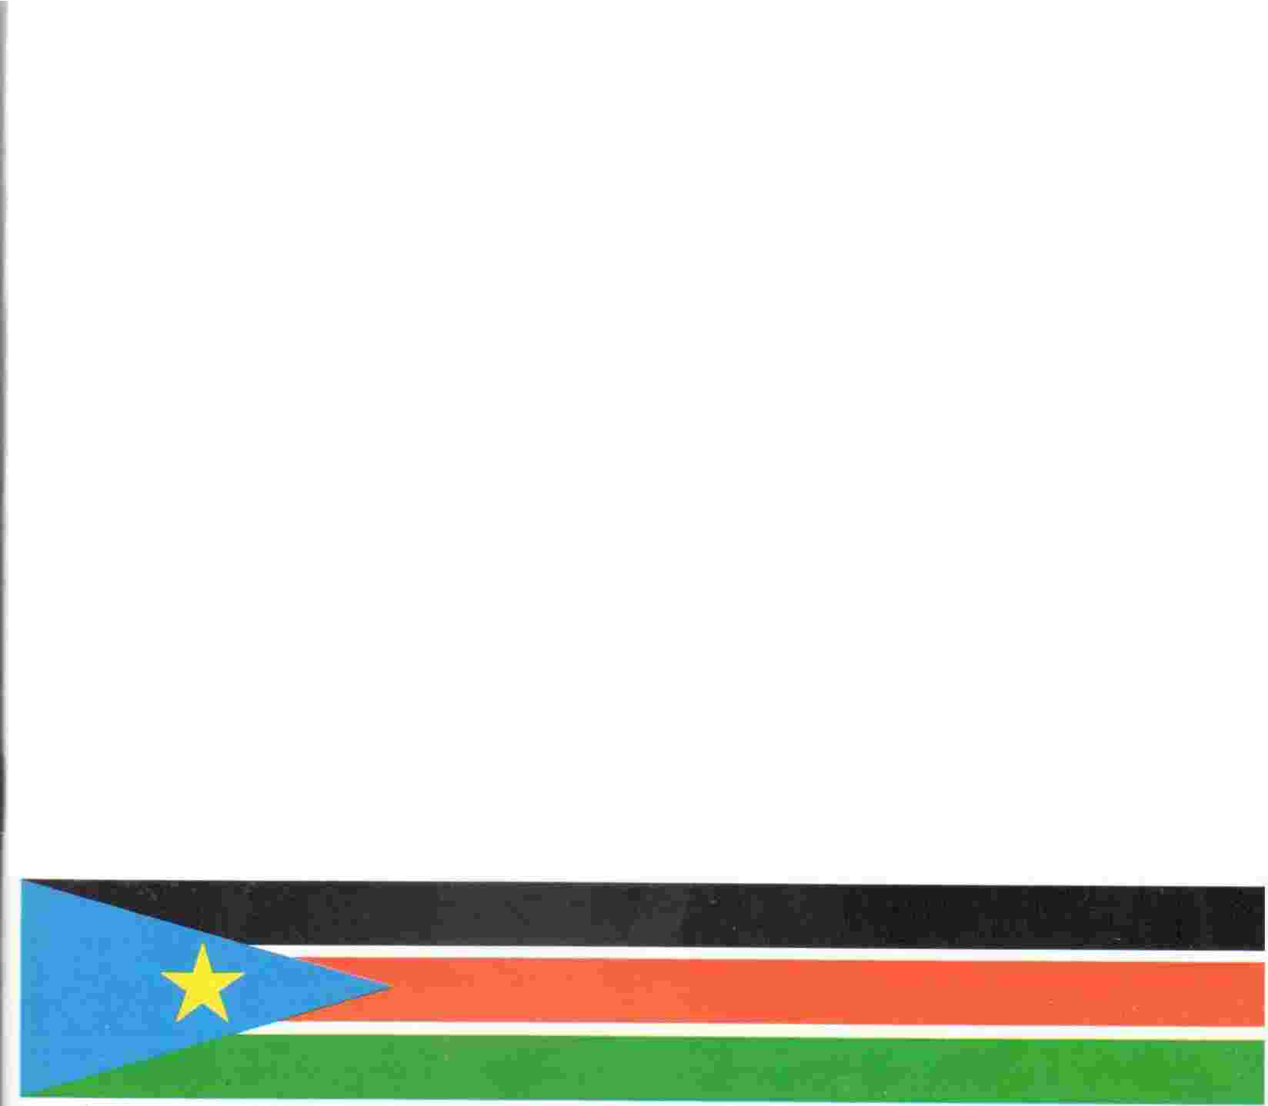

REPUBLIC OF SOUTH SUDAN
Office Of The President

THE SPEECH OF H.E THE PRESIDENT ON THE OCCASION

OF THE OPENING OF THE TRANSITIONAL NATIONAL LEGISLATURE [TNLJ OF THE TRANSITIONAL GOVERNMENT OF NATIONAL UNITY, AUGUST 15TH, 2016•

•

• Your Excellency , First Vice President of the Republic,

• Your Excellency , Vice President of the Republic,

• Right Honourable Speakers of the Transitional National

Legislature,

• The Honourable Chief Justice

Honourable Members of the Council of Ministers

• Honorable Members of this August House,

• Members of the Diplomatic Corps,

• Distinguished Guests, Ladies and Gentlemen,

Today is a great and historical day for South Sudan as we officiate the establishment of the expanded Transitional National Legislative Assembly (TNLA) of the Transitional
Government of National Unity (TGoNU) in fulfillment of

The Speech of H.E The President on occasion of the opening of TNLA, August 15th, 2016

Page 1
Chapter I, Article 11 of the Agreement on the Resolution of the Conflict in the Republic of South Sudan (ARCSS). Some of you may know that the TNLA should have been established ninety (90) days from the date of signing the ARCSS. Unfortunately, we failed to meet that deadline due to petty political differences and lack of cooperation that occupied much of our working relationship with the Former Leader of the SPLM/ A• IO, my brother Dr. Riek Machar Teny, who was also the First Vice President of the Republic.

At this juncture Rt. Hon. Speaker and Honourable members, allow me to congratulate those of you who are new in this august House for the confidence your party vested upon you to represent your people. Also I would like to congratulate
Honourable Anthony Lino Makana, for the trust given to him

The Speech ofH.E The President on occasion ofthe opening of TNLA, August 15th, 2016

Page 2

by the Caucus of Greater Equatoria and the larger SPLM to lead this august House as the Right Honourable Speaker. This is a very important responsibility that requires patience, tolerance and leadership. I know that Honourable Anthony Lino Makana can do the job and I advise him to embrace all of you without regard to the party you represent. That is the only sure way of success to build nationalism, which South Sudan badly needs.

Rt. Hon. Speaker, Honourable Members, Ladies and

Gentlemen
In this connection, I would like to sincerely express my thanks and appreciation to the new leadership of the SPLM/ A-IO, under the stewardship of Comrade Taban Deng Gai, for showing a new spirit of cooperation objectivity and

The Speech of H.E The President on occasion of the opening of TNLA, August 151h, 2016

Page 3
commitment that has enabled us to establish this August House this 15th day of the Month of August, 2016, within a short period of time after his appointment as the First Vice President of the Republic of South Sudan. This is what was lacking and I pledge to you, my people, that I will work closely with General Taban Deng Gai and his colleagues in the SPLM/ A-IO to implement the ARCSS in letter and spirit in order to rescue our country and people from the unbearable situation in which they are now in.

Rt. Hon. Speaker, Honourable Members, Ladies and
Gentlemen

When we achieved our independence after decades of a brutal liberation struggle and established South Sudan as a Sovereign
.. Member State of the Untied Nations in 2011 we had a dream of

The Speech of H.E The President on occasion of the opening of TNLA, August 151h, 2016

Page 4

transcending conflicts and ethnic strife; a dream of unity, economic independence and eventual prosperity.

We believed and still believe that we can escape the dreaded "Curse of Africa": the perpetual ethnic and tribal discord, violence and the political instability and dysfunction which have sadly characterized so many African Countries in the last fifty years.

We believe we can do much better than that. We can learn from the experiences of others, so that we do not repeat the mistakes that constrained so many of African leaders and led to their failure to develop their countries and deliver services to their people. I still believe in that dream. I am confident we can turn
our experience and challenges into success despite the current

The Speech of H.E The President on occasion of the opening of TNLA, August 151h, 2016

Page 5
.
political instability and insecurity that some people want to

make a trade-mark of South Sudan.

Rt. Hon. Speaker, Honourable Members, Ladies and

Gentlemen

We are in the midst of a process of nation- building, which is difficult and those who have not gone through such an experience may not appreciate the magnitude of our concerted efforts to build this new nation. The ARCSS has given us another opportunity to work together and build our country as one people. We may have different political affiliations and aspirations, but our country and people must come first and above all.

•

The Speech of H.E The President on occasion of the opening of TNLA, August 151h, 2016

Page 6
This Assembly is a very important institution and it has a lot to deliver in the context of the ARCSS. You will not achieve what the people of South Sudan expect of you if you do not work together and support its new leadership.

Therefore, I call upon you all, Honourable members, to tolerate each other and cooperate amongst yourselves so that you do what is expected of you in the coming months.

Rt. Hon. Speaker, Honourable Members, Ladies and

Gentlemen

I say this to all of us, including those who unfortunately chose not to be here today, that we mode mistakes in the past five
years since our independence, costly mistakes that could have

The Speech of H.E The ". ·esident on occasion of the opening of TNLA, August 151h, 2016

Page 7
been avoided if we did things differently. Now we have learnt from those mistakes and must stand resolute and do our best to correct them.

Therefore today, on this historical occasion I want to set out some ideas which we have been deliberating on and thinking about for weeks if not months. These are ideas we believe will mitigate our plight, change our course and take us into a brighter future.
1. We need a new, comprehensive national policy, one that I hope will lay solid foundations for both the immediate and distant future.

First and foremost, let me be crystal clear and emphasize to our people and to the world:

The Speech of H.E The President on occasion of the opening of TNLA, August 15th, 2016

Page 8

The Transitional Government of National Unity in South Sudan is committed to the peace process and its implementation. We are aware that the implementation was imperfect and flawed in some respects.

There are no ifs, buts or qualifications. Our commitment is our word and it is rock-solid:

2. We are fully committed to the peace agreement of August

2015 and its continued implementation.

I call on all parties and opposition groups to be a part of this most cherished commitment.

The Speech of H.E The President on occasion of the opening of TNLA, August 151h, 2016

Page 9
This is our country. We have built it from scratch after a prolonged, bloody and heroic struggle. Let us work together to keep it together to preserve its present and guarantee its future.

Rt. Hon. Speaker, Honourable Members, Ladies and

Gentlemen

The road to prosperity should be paved with unity, not divisions; with goodwill and hard work, not endless futile conflict. With respect to international involvement and intervention, there are a few things that need to be explained precisely.
South Sudan is not instinctively or automatically against IGAD

and UN involvement.

The Speech of H.E The President on occasion of the opening of TNLA, August 15th, 2016

Page 10

We welcome assistance, we are attentive to advice. But assistance requires dialogue, it should not turn into an imposition that becomes an intervention, in which our sovereignty is compromised and our ability to govern effectively diminishes rather than increases. More and better could and should be achieved through consultation and dialogue.

South Sudan has no regional enemies. The UN's role is no doubt critical and the support and friendship of the US is invaluable to us. The US and President Obama stood by us before, during and after independence and I hope and pray the
US remains our ally and friend.

The Speech of H.E The President on occasion of the opening of TNLA, August is« 2016

Page 11
It is true that TGoNU have very serious concerns about the decisions taken by IGAD in its communique of the 5th August,
2016, and on the Renewed UNMISS Mandate based on the proposal advanced by the United States of America, which was adopted last Friday the 12th August, 2016, by the United Nation
Security Council. But we will discuss the details with those of UNMISS, the UN and its partners to find the best way of implementing and achieving our mutual interests.

Already there are people who are accusing the TGoNU of refusing and fighting the UN. I want to confirm on this great day that this is not an accurate appraisal of our position. The TGoNU has not met to deliberate on the final position taken by the UN Security Council. If there are voices out there
expressing their view on the subject, these are individuals who

The Speech of H.E The President on occasion of the opening of TNLA, August 151h, 2016

Page 12

do not represent the TGoNU and have certainly not been mandated to speak on behalf of the Transitional Government of National Unity.

Indeed we need to be engaged in a discourse and exchange ideas on what is the best way forward, rather than be presented with a fait accompli from outsiders. This is a recipe for a weakened and diminished South Sudan that will sink into despair. They may mean well, and I believe they have good intentions, but the consequences of hasty and imposed decisions may be dire. For good intentions are not necessarily always reflected by decisions made thereon.

The transition from liberation struggle to statehood exposed a gap in military-civil relations. Our military is yet to be fully

The Speech of H.E The President on occasion of the opening of TNLA, August 15th, 2016

Page 13

indoctrinated in line with the duties of the military in peace time and within the context of a fully fledged independent
democratic state where the military is completely subordinate
I
J to the authority of a civilian Government.

In addition we still have to achieve military uniformity. Thus, military-civilian relations will have to be brought to maturity. We will introduce broad reforms on how the military is structured and functions. This reform process will go into effect by January two thousand and seventeen.

Rt. Hon. Spe.aker, Honourable Members, Ladies and

Gentlemen
(
I
I There have been allegations and reports of various cases of

sexual assault. This is a serious matter. I would like to

The Speech of H.E The President on occasion of the opening of TNLA, August 15th, 2016

Page 14

unequivocally stress: We will show zero-tolerance toward such incidents. We have already begun an initial investigation and we are reviewing medical reports, and intend to prosecute those who will be found involved.

On another pressing and very disconcerting issue, we will appoint a commission of inquiry to investigate the circumstances, causes and culprits responsible for food and medical supply theft in the aftermath of the July events. This is an unacceptable crime against the people, individually and collectively, affecting entire communities.

To achieve these ideas and implement these plans, I believe we need a renewed mandate and trust from the people. I will therefore consult with other political leaders and peruse our

The Speech of H.E The President on occasion of the opening of TNLA, August 151h, 2016

Page 15
transitional Constitutional provisions in order to reach general consent on expediting the electoral process.

These are major steps comprising a new comprehensive policy charting a course for a better future. As part of this commitment, I pledge that the transitional national government will continue to function, be inclusive and avoid any and all forms of political exclusion. Because of the transitional and temporary nature of the unity government, we do not have a formal opposition, except such opposition as will be dictated by our own individual conscience on some issues we may differ on.
Have no doubt, Ladies and Gentlemen, that I expect and

welcome opposition. This is because it is an integral part of

The Speech of H.E The President on occasion of the opening of TNLA, August 151h, 2016

Page 16

the spirit and substance of democracy; and it is real democracy that we have always struggled to establish in our country.

Let me reiterate this: In an effort to work toward reconciliation, we will establish an official commission of inquiry to fact-find and investigate the causes, context and immediate reasons for the outbreak of violence last July. A former judge will head this commission and its members will be carefully selected mainly on the criteria of objectivity and impartiality. My office will ensure that the commission has unhindered access to information. I invite UN Secretary General Ban Ki-Moon and IGAD countries to appoint a representative to be part of the
comrmss1on.

•

The Speech of H.E The President on occasion of the opening of TNLA, August 151h, 2016

Page 17

the spirit and substance of democracy; and it is real democracy that we have always struggled to establish in our country.

Let me reiterate this: In an effort to work toward reconciliation, we will establish an official commission of inquiry to fact-find and investigate the causes, context and immediate reasons for the outbreak of violence last July. A former judge will head this commission and its members will be carefully selected mainly on the criteria of objectivity and impartiality. My office will ensure that the commission has unhindered access to information. I invite UN Secretary General Ban Ki-Moon and
!GAD countries to appoint a representative to be part of the

comm1ss1on.

•

The Speech of H.E The President on occasion of the opening of TNLA, August 15th, 2016

Page 17

Furthermore, I understand the concerns regarding the safety and wellbeing of NGO staffs, aid and medical agencies and displaced South Sudanese in camps. I instructed the Ministers of Defense and National Security to create a safe environment throughout the country that would make their movement and activities unthreatened and uninterrupted. They are here to help us and it is our practical responsibility and moral duty to make sure they are safe. It deeply pains me to see the people who courageously fought and established this great country finding themselves in need of protection from their own security forces composed of their own sons and daughters.

We will ensure the safety of all the citizens and expatriates wherever they are in the country and avoid our citizens'
continued stay in Protection of Civilian (POC) sites. To achieve

The Speech of H.E The President on occasion of the opening of TNLA, August 15th, 2016

Page 18

this, deliberate plans are on the way to make this a reality. As part of this plan, by the first quarter of two thousand and seventeen the safety of the people of our capital will be under the full jurisdiction of specially trained civilian police and not military units. We will make our cities safe cities like other major cities in the world.

Rt. Hon. Speaker, Honourable Members, Ladies and

Gentlemen

I have had sleepless nights and spent every moment of my day thinking about a South Sudanese child who is hungry in a village.

On the economy, sustainability and future prosperity are our national priority. We are experiencing severe economic

The Speech of H.E The President on occasion of the opening of TN LA, August JSch, 2016

Page 1 S

difficulties and the hardships affecting so many of our people who deserve better living conditions. However, the goal to change this situation of hardships is our paramount objective
now. And to achieve these objectives:

1. We are working tirelessly to increase oil production so as to enhance the flow of hard currency.
2. We are working on means to improve and control our non-oil revenue collection. These means include the use of our Revenue Authority Bill that we signed into law in
2015.

3. To ensure market control mechanisms that would

stabilize prices of essential commodities including the use of subsidies when necessary.

The Speech of H.E The President on occasion of the opening of TNLA, August 151h, 2016

Page 20

4. Road infrastructure is also a key requirement, especially for ferrying goods and commodities to various towns and villages in our country. Plans are already underway to make our roads all-season roads.

5. In order to achieve these, a unified plan has been developed - SEED (South Sudan Extended Economic Development). This development plan includes extensive infrastructural investment in roads, transportation and electricity as well as solid financial structures.

By ensuring food sustainability and strengthening the foundations of our economy based on the above mentioned
plan (SEED) we can look forward to a bright future. As part of

The Speech of H.E The President on occasion of the opening of TNLA, August 151h, 2016

Page 21

this broad plan, agricultural expansion, introduction of irrigation systems and industrial development shall usher in a diversified economy. We need a balanced economy; we cannot rely on an oil-based economy alone.

For this plan to succeed, we need international assistance: from the World Bank, the African Development Bank, International Monetary Fund (IMF) and the private sector.

The unnatural reality of one country and two armies coexisting side by side is dysfunctional and already proven to be disastrous as :we witnessed during July's tragic events. There will be one national army by May first, two thousand seventeen. Last week, I instructed the army Chief of General
Staff to start the process. Matters of recruitment, training,

The Speech ofH.E The President on occasion of the opening of TNLA, August 15th, 2016

Page 22

promotions, command and rrussions will be professionally determined and based on merit, not according to ethnic or political affiliations.

We are one nation. Our military is a defense force. The military's task includes, among others, assisting the country in all aspects of nation building, economy, agriculture, and infrastructure. With respect to military code of ethics and policy, the military will introduce and commence a broad educational campaign on military conduct with the general public. Before any military assignment, officers and soldiers will be briefed on proper conduct and behavior. Any aberration will be reported immediately and dealt with
accordingly. Failure to report would be considered a breach of

The Speech of H.E The President on occasion of the opening of TNLA, August 151h, 2016

Page 23
command responsibilities. The military will form a tribunal, headed by a General to oversee implementation of this policy.

As I mentioned before, and effective immediately, all abuses and sexual assault allegations and incidents involving military personnel will be investigated and those found responsible prosecuted and court- martialed to the fullest extent of the law.

Lastly, there is the issue of guns. There is an abundance of unregistered firearms in the hands of the military and other organized forces, as well as those being held illegally by civilians. We will initiate registration in the military and collect these weapons, enforce regulations and the law and prosecute
offenders. The idea of unauthorized civilians carrymg

The Speech of H.E The President on occasion of the opening of TNLA, August 15th, 2016

Page 24
weapons is unacceptable and TGoNU will design a strategy and programme of comprehensive disarmament.

Rt. Hon. Speaker, Honourable Members, Ladies and

Gentlemen

In the coming days and weeks, these principles will become binding guidelines and where appropriate via legislation, transformed into law. Political parties are part and parcel of democracy. But for a country in the process of nation -building, they have also been a source of fragmentation, confrontation and paralysis.

I am calling here for the establishment of an inter-political all - South Sudan public council. Experts from all fields, ordinary

The Speech of H.E The President on occasion of the opening of TNLA, August 15th, 2016

Page 25

citizens from all walks of life, tribal representatives, old and young, professionals and students will convene twice a year and engage in a discourse on the direction of the country. This will not eliminate differences but will create the forum and mechanism to debate them in a civil and open way. I believe this idea, together with our New Policy which my ministers worked hard to develop, will enable us to set a new course for all, but especially for the children of South Sudan.

Rt. Hon. Speaker, Honourable Members, Ladies and

Gentlemen

The Speech of H.E The President on occasion of the opening oJTNLA, August 15th, 2016

Page 26

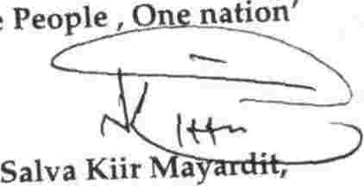South Sudan may be an infant in political and historical terms but have faith; Together we will succeed in achieving our dream of being 'One People
President of the Republic of South Sudan

Juba

•

The Speech of H.E The President on occasion ofthe opening of TNLA, August 15th, 2016

Page 27

